VALGOT SUSHMITA | ✆+91- 9347398239  Email: valgotsushmita@gmail.com

CAREER SUMMARY
An organized professional with global experience, highly motivated, Enterprising, hard-working and technically skilled, performance driven, analytical professional, quick learner and high on energy. Excellent interpersonal skills, written and oral communication skills, strong desire to lead and succeed high powered customer focused teams with over 3+ years of professional experience known for displaying unparalleled people and accuracy, attention to detail and timelines in managing disbursement functions for diverse- industry employers and gather relevant experience and rise through corporate hierarchy to top position by making the best use of human, material and capital available and thus develop a symbiotic relationship with the organization. Looking forward to enjoy being the part of a motivating and productive team.

KNOWLEDGE PREVIEW
- 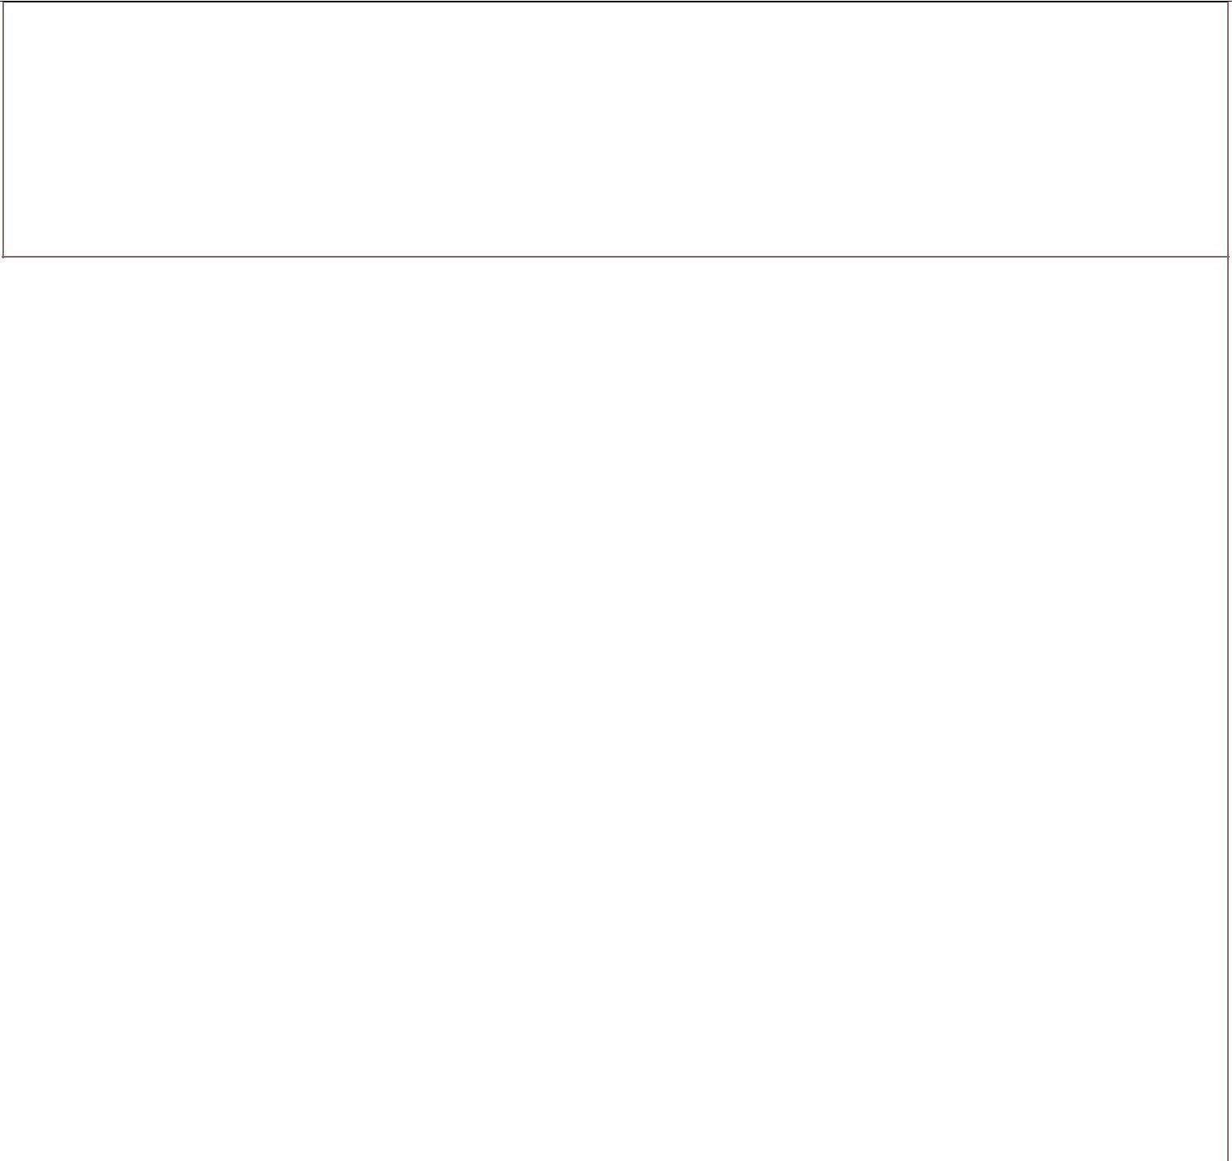Having 3+ Years of experience in the Software Testing along with Agile Scrum Certified Tester using traditional and agile methodologies on Manual (1.7Years)and Automation Testing (2Years).

- Good Experience in User stories, product backlog, Sprint backlogs. Involved in daily standup meets and preparation of Sprint Burn down Chart and attended for various meetings like Product Grooming, Review, Retrospective and Refinement etc.

As Test Automation Engineer

- Involved in Framework Design and created an Architecture using TestNGs, pom.xml and testNG.xml etc.
- As a team we are following Hybrid Framework, having knowledge on POM .
- Good knowledge on test Script development and its maintenance, page factory model
- As a team we were following POM for protractor
- Strong at Xpath axes.
- Worked on Jenkins for CI.
- Used GIT to Push and Pull the latest codes
- Having exposure on other Automation tools like:

➔ Web based Applications using Selenium,
➔Web based Applications using Protractor
As Manual Tester

- Understanding User stories. Sending mails to get clarity on queries.
- Good knowledge on SDLC and STLC and DLC processes and procedures.
- Associated with Scrum Master in TestPlanning, Test deliverables Designing and Scheduling, Resource utilization plan
- Involved on client calls, Task Assignments
and Daily Status Report sending etc.
- Involving in Test Design, plan maximum coverage of requirements with optimal coverage of test case creation.
- Good exposure on JIRA like Test Management tools. Maintenance of Test Plan, Test Lab, Defects tracking & triaging analysis.
- Having good exposure on Defect tracking tools like Qtest .
- Knowledge of Functional testing, Regression testing, Sanity testing , Smoke testing, Test case preparation, Bug report.
- Having knowledge on API Testing using Postman tool.
- Used JMeter for performance Testing

~ 1 ~

  - Good on Team Building, Client Complaints Resolution, Training and knowledge checkers, Proactive Decision making, Fraud Analysis & Payment Monitoring.
  - Provide support, expertise and oversight on serious and complex situations and Responsible for sending queries or End Day / Status Reports to Manager and Clients.
  - Good interpersonal skills, commitment, result oriented, hard working with a quest and zeal to learn new technologies and undertake challenging task.
  - Proven ability to work efficiently in both independent and team situation with positive results.

TECHNICAL SKILLS:
Bug Tracking Tools | : JIRA,Qtest
Test Support Tools | : Selenium, TestNG,Protractor
Languages known | : Core Java,Javascript
Operating systems | : Windows 2007, 08, 10
Data Base | : SQL,MangoDB
API Tools | :Postman
Performance Testing tools | :JMeter
CI Tools | :Jenkins
Code Repository | :GIT

ACHIEVEMENTS
- Got several “Star Performer of the month” awards for excellent performance.
- Suggested process improvement ideas within the process.
- Successfully and consistently met all client SLA’s (Service Level Agreement)
- Provided resolutions to the client queries in a quick TATs. (Turn Around Time)

CERTIFICATIONS
- Feb 2018Java course certified by Solo Learn
- Jan 2018Sql Fundamental course certified by Solo Learn

PROFESSIONAL EXPERIENCE
- Software Engineer-QA (Nov 2016 to JUN 2019) at Hi-Gate Info systems Pvt.ltd

PROJECT#1

Project | : | GetMeAShop
Environment | : | Web,APP
Automation Language | : | Selenium
Client | : | GetMeAShop
Role | : | Software Engineer-QA
Project Description:
GetMeAShop commonly known as GMAS, is an E- commerce services provider. The Company Provides Ecommerce Solution to their clients in India as well as for foreign Clients. As of March 2015, the company provided services to just over thirty thousand subscribers and has approximately 1000 employees.
GetMeAShop is a Middleware Application, That Support clients to upload their product via their backend panel and they can sell these product via own domain website .GetMeAShop was acquired By The Times of India In the year of 2015.

~ 2 ~
- QA Engineer (JUL 2019 to Present) at Quovantis Technologies

PROJECT#2

Project | : | Pareo
Environment | : | Web
Automation Language | : | Protractor
Client | : | CLARIS HEALTH
Role | : | QA Engineer
Project Description:
Pareo is an Healthcare services provider. The Company Provides Healthcare Solution to their clients in USA. Pareo is the only Industry’s comprehensive payment integrity platform that maximizes health plan avoidance and recoveries at the most optimized cost
PAREO is a Middleware Application, That Support patients to upload their claims via their backend panel and they can get audited the medical bills via own domain website

Responsibilities:(As Test Automation Engineer):
- Involved in Design an Architecture and create Page Object model Framework.
- Developed and Test Scripts using Java in Selenium and provide provision to quick data changes externally (Excel Sheets (data) & Text files (requests)).
- Modify and update (maintain) the code as per new changes and control over the check points, Recovery scenarios etc.
- Setting Property values Project / Suite / Test Case level and getting them where required.
- To judge the Application, will maintain expected result externally and compares with Actual.
- Log the defects with complete description and tracked for their status using JIRA.
- Create New Test scenarios and write code for the same .
- Push new code on git and pull the same on remote server.
- Jenkins configuration & maintenance

Responsibilities: (As Manual Tester)
- Understanding functional requirements/ User Stories form JIRA and identified test conditions.
- Analyze the requirement coverage and traceability to ensure the testing coverage’s, sending queries
to on site to get clarity on requirements.
- Creation of Test Cases on Test plan to map based on functional requirements to crate/review and Execute test Sets .
- After creation of all the RFC’s review it once again if required need to update as per new changes.
- verify and validate the scenarios and if found variation then log Defect defects and tracking them till closing of Defect.
- After completion of No-Run concentrate on Re-Run for 100% test pass conditions.
- Apart from the above used to
1). Conduct Smoke test and assist Scrum Master to scheduling the test plan and procedures. 2). Task assignment as per the onsite mails/ defects under retest / No run / Re run status
3). Discuss with onsite coordinator through mail and share the knowledge and chat regarding Expected outputs with developers through linc.
4) Also responsible for DSR (Daily Status report/ Weekly health report / Monthly Engagement Report / Requirement Traceability Matrix / Query log / Test Data / review reports like test Deliverables.

EDUCATION

- B.E(ECE) with 70% from JNTU Hyderabad | 2015
- 10+2 With 86 % from Sri Chaitanya Hyderabad | 2011
- 10th with 75 % From Gowtham Model school | 2009

~ 3 ~

